**SEVEN (7) MONTH ROYAL PALM INVESTMENT PORTFOLIO DATA ANALYTICS REPORT**

**Date:** 21st March 2025

**Prepared By:** Kajola Gbenga

**Submitted To:** UMéRA Management Team

**CONTENTS**

1. Introduction
2. Key findings & Insights on Investments
3. Age Segmentation Analytics
4. Affliates Analytics
5. Recommendations
6. Conclusion

### ****1. Introduction****

*This report presents a* ***seven month*** *in-depth analytics of the Royal Palm investment portfolio data for the period spanning* ***July 2024 to January 2025****. The objective is to identify trends, investors’ behaviour, distribution of investments across different land types and unit types, age segmentation and most importantly a robust analytics on the affiliates and their pivotal roles during the seven month period.*

### ****2. Key Findings and Insights on Investments from July 2024****

#### ****2.1 Investment Trends Over Time****

* The highest number of investments were recorded in **July 2024**, followed closely by **August 2024 where a uniform curve was experienced for three months till the end of **October 2024****.
* A notable **decline** in investments was observed from the beginning of **August 2024**, which may indicate seasonal investment behavior or other external factors affecting investor decisions.
* A steady **uniform trend** was observed from **August 2024 to October 2024**, showing a rapid drop of the investor interest compared to **July 2024**.

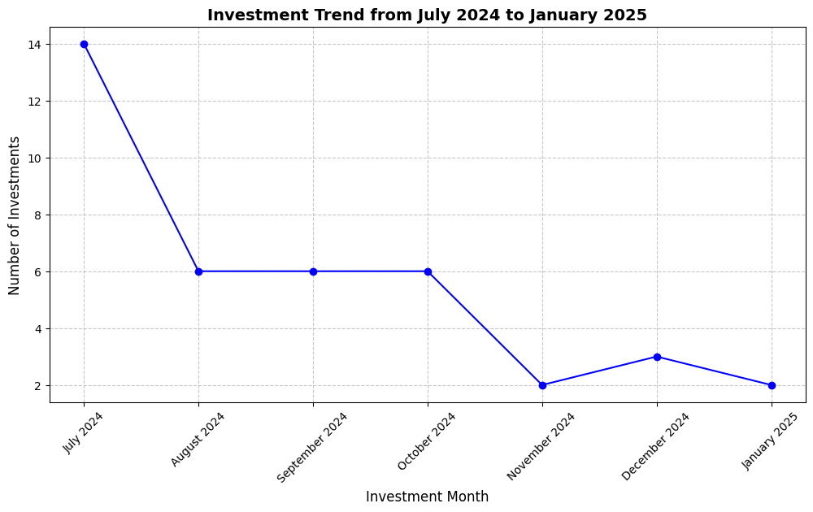

#### **2.1 **Investment Distribution by month and Land Type****

* Based on the first heatmap visualization below coupled with the two bar chart visualizations that accompanied it, **July 2024** which had the highest number of units bought ushered in a whopping **70 Million Naira**.
* The second heatmap analytics which is the fourth chart below revealed that some land categories had **consistent investor engagement** across multiple months, while others were sporadic.
* Certain land types witnessed **higher demand in specific months**, which may be due to marketing efforts or seasonal investor preferences.
* Pie chart analysis indicated the summation of the investment distribution by land type bought during the period analyzed with Acre cutting the largest portion of it with a **71.8%** percentage while Plot took **28.2%**.
* A clear **shift in investor preference** for multiple number of units was overwhelmingly noted in **July 2024**, possibly due to promotions or new offerings.
* Although the amount of units dropped in **August 2024,** and a steady **uniform trend** in the units bought was observed from **August 2024 to October 2024**, showing a consistent run of the investor interest compared to **July 2024**.
* A super rapid decline was experienced from **November 2024** till **January 2025** although in between **December 2024** showed a slight increase in the total number of units bought which could be as result of some promotions cause more Acres were bought unlike the preceding month where the sales performance was below par.
* Similar to land type trends, Acre land type **experienced higher demand**, while the Plot land plot had minimal investor participation although had some substantial sales trajectory just in **August 2024** & **September 2024.**
* **January 2025 recorded another significant drop**, common analytical reports suggest it could be as a result of it being the beginning of the year, and most investors might be conscious of the investment they want to invest in and also other reasons pertaining to sorting out the bills for the month of January which is mostly regarded as the planning month of the year.

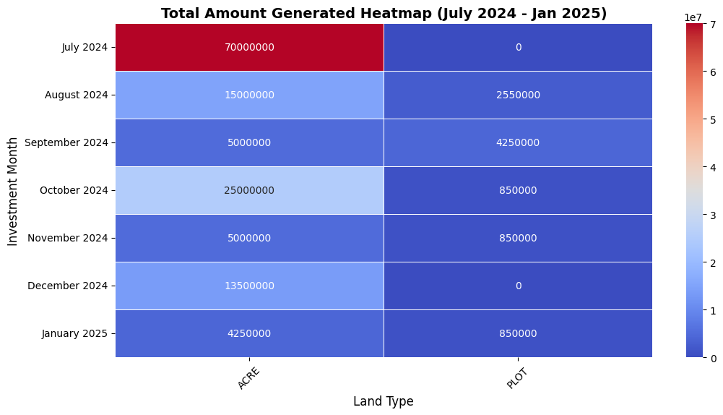

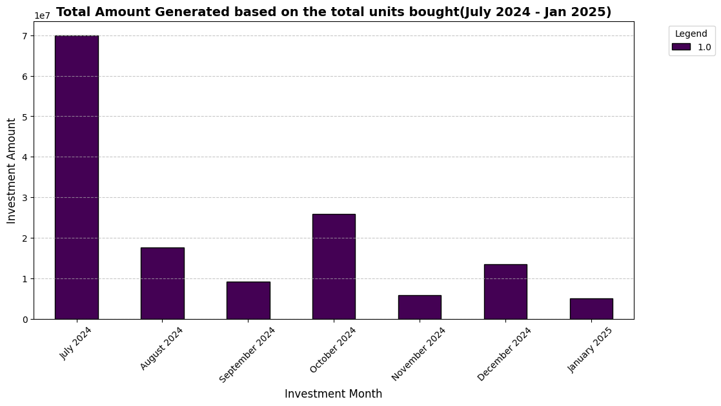

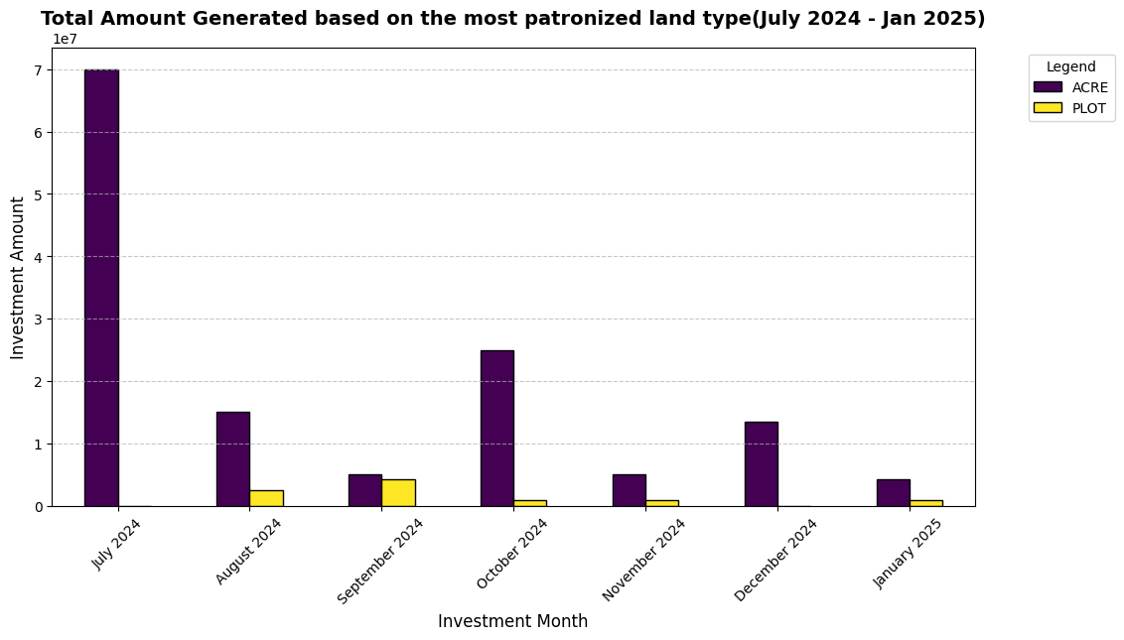

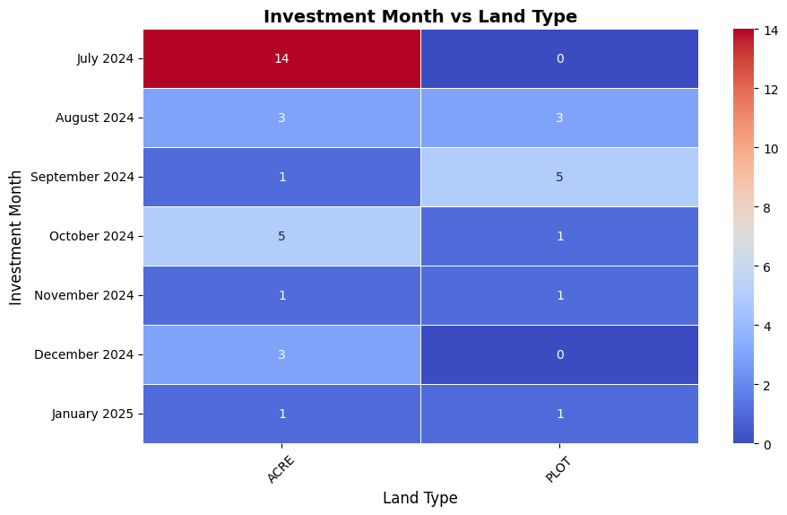

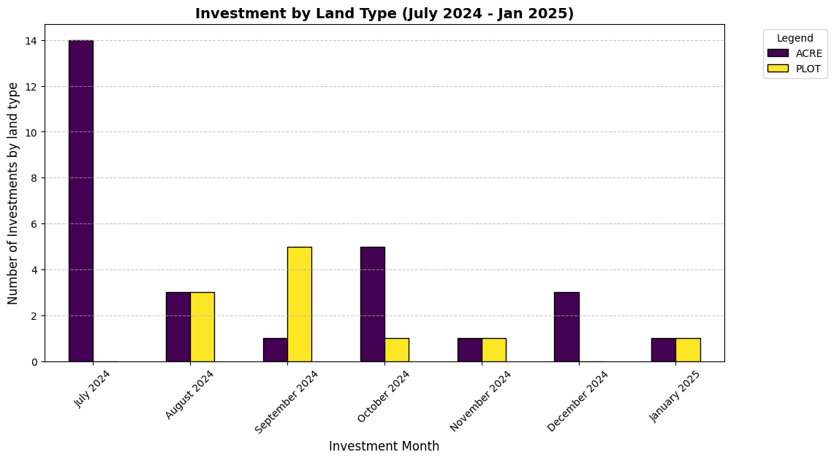

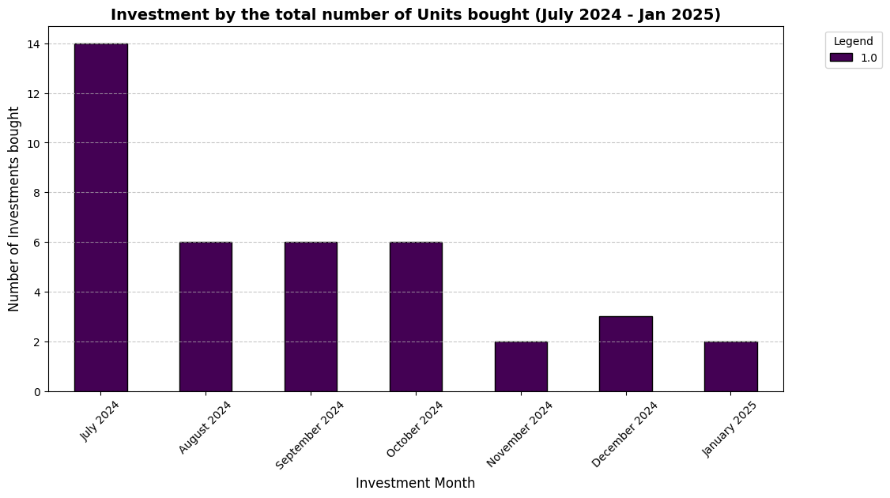

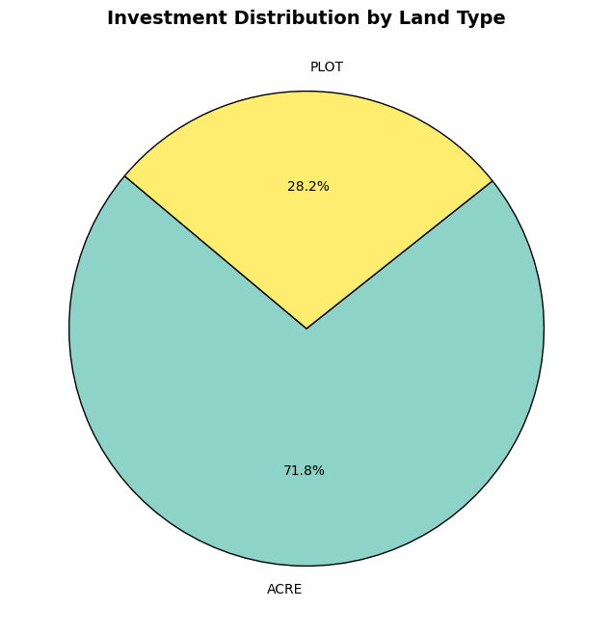

### ****3. Salient Insights from the Age Segmentation on Investments from July 2024****

#### ****3.1 Investment Amount by Age Group & Month****

* The most dominant Age group is **40-49** where there was consistent patronize from the inception which is **July 2024**, all the way till **January 2025.**
* A whopping **61.8 Million Naira** was made by the **50-59 Age group** showing that more amounts was invested by this Age group although a rapid three month decline was observed after the end of **October 2024**, whereby there was no single patronize during the three investment hiatus.
* Pie chart analysis indicated the summation of the total investment distribution by age group bought during the period analyzed with **50-59 Age Group** cutting the largest portion of it with a **53.2%** percentage while **40-49 Age Group** took **32.5%**.
* More amount was invested in **October 2024** with the **50-59 Age Group** the only set that invested in that particular month, and closely followed by **July 2024** where **40-49**, **50-59** & **60-69 Age Groups** were the only three sets that invested in that particular month.
* Based on the analytics of the age groups with respect to the land types bought, **40-49 Age Group** bought more Acres than plots, **50-59 Age Group** which has the highest percentage bought more plots than acres, **18-29 Age Group** was tied with the equal amount of acre and plot, same with **30-39 Age Group** which was tied same with the 18-29 Age Group, while the **60-69 Age Group** performed poorly with just a single Acre bought during the seven month.

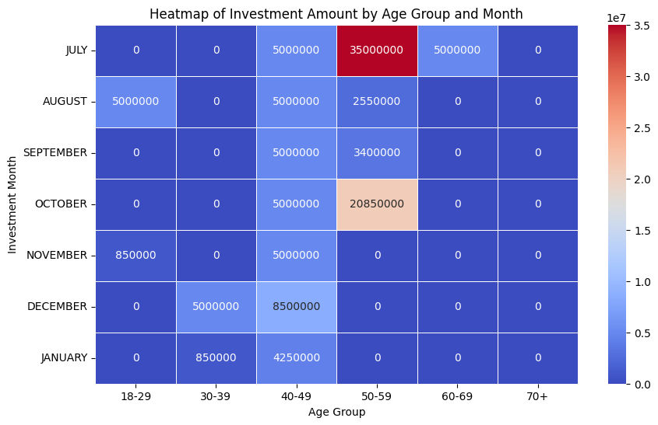

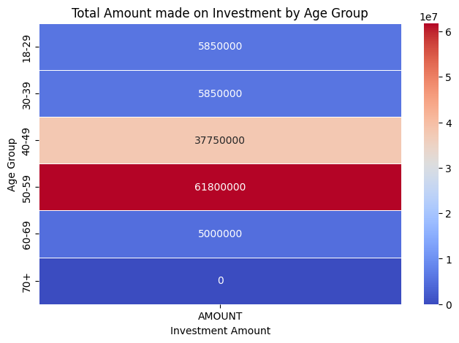

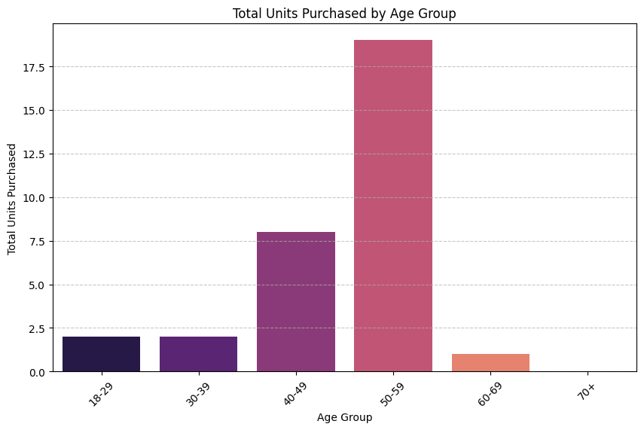

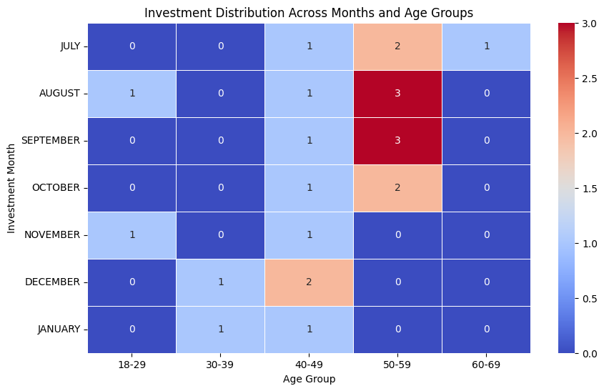

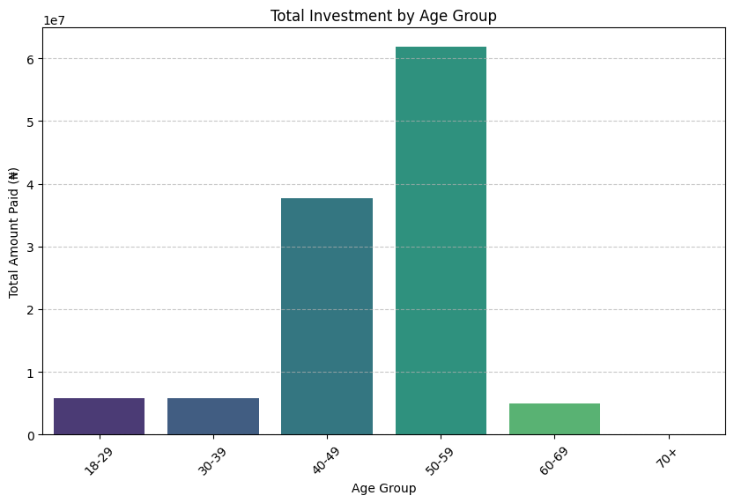

### ****Pie Chart Proportion of Investments by Age Group****

### ****4. Salient Insights from the affiliates analytics on the Investments made through from July 2024****

* More Investors were massively recorded in **July 2024**, and closely trailed by **August 2024** where three investors came via affiliates, then no investor was recorded during the remaining five month except in **October 2024** where just one investor was recorded via affiliates.
* Out of the seven month period where the analytics was carried out on, investors came via affiliates in just three months which were in **July 2024**, **August 2024** and **October 2024**.
* Based on the Doughnut chart analysis indicated below in the third image below, customers that came via affiliates were lower accruing a lower **30.8%** percentage compared to the customers that didn’t come through affiliates which had a massive **69.2%**.
* **Mr. Kiki Michael brought in a whopping Six(6) investors which is the highest and unmatched by the other two affiliates that trailed him by one(1) each; who are Ms. Ajagun Jesuseuntitun and Mr. Emiko Okome.**

### ****Heatmap of Affiliate vs Non-Affliate Customers****

### ****Growth Trend of Affliates****

### ****Doughnut Chart Affiliate vs. Non-Affiliate Customers****

### ****Number of Customers Through Affiliates Per Month****

### ****Stacked Area Chart Trend of Affiliate vs. Non-Affiliate Customers Over Time****

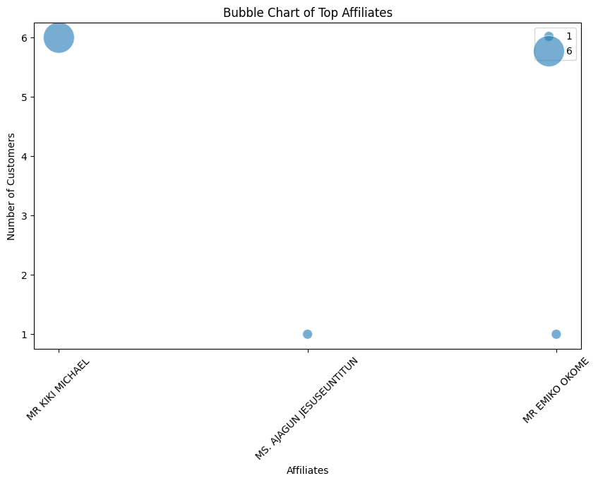

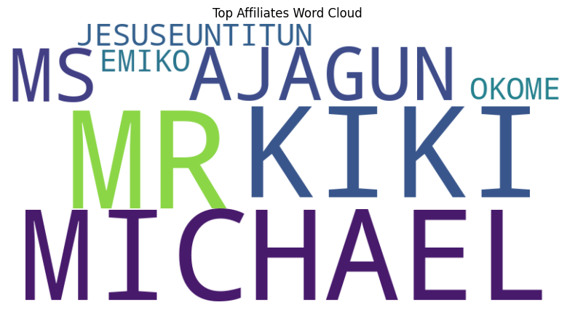

### ****5. Recommendations****

*Based on the insights derived from this analysis, the following recommendations are proposed:*

* + Enhance marketing efforts in months that show strong investor activity (e.g **July**).
  + Introduce more **incentives or promotional offers** in months where investments decline (e.g **November 2024 to January 2025**).
  + Since more money was invested in **October 2024**  and closely followed by **July 2024**, so more attentions on sales increase should be placed on those two months as well as intense marketing should be placed on the other five months where the sales recorded was substantially lower.
  + While checking the 3D affiliates chart which is the third image below, where more investors came via affiliates in just three months so ways should be to get more affiliates on board with packages and benefits to entice them.

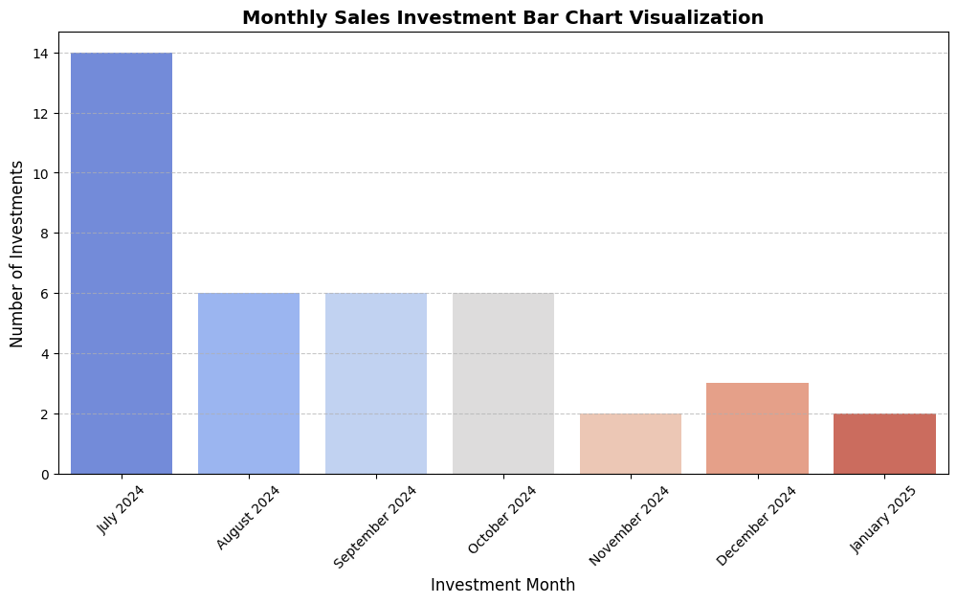

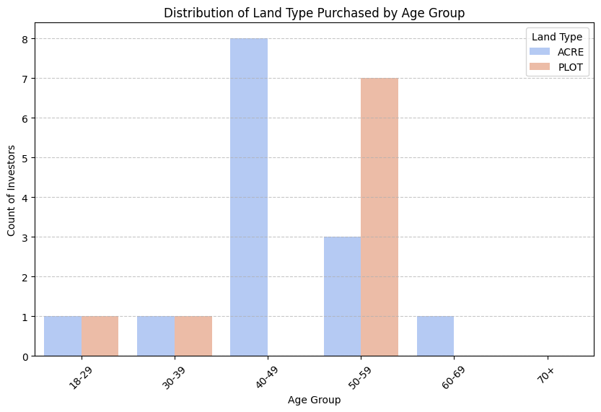

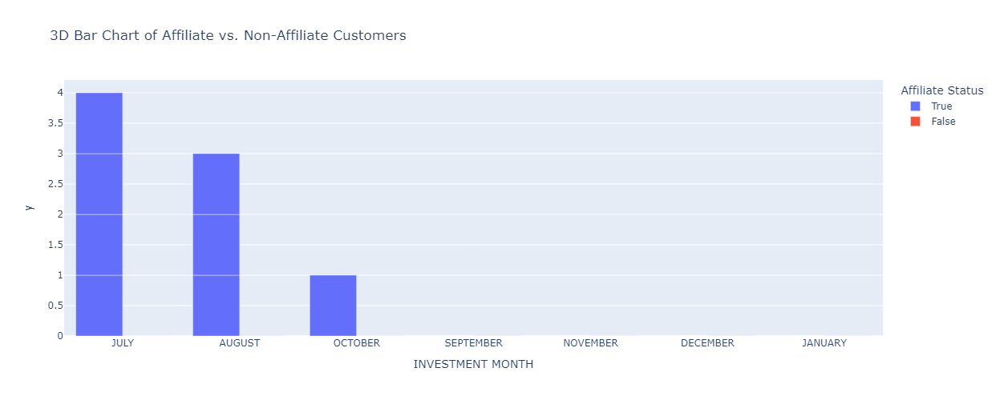

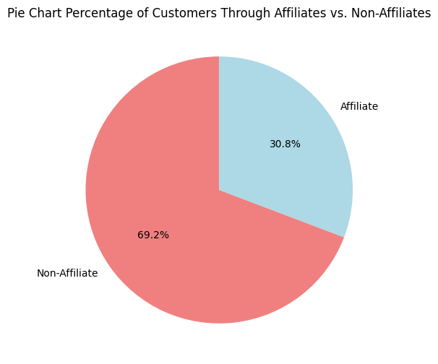

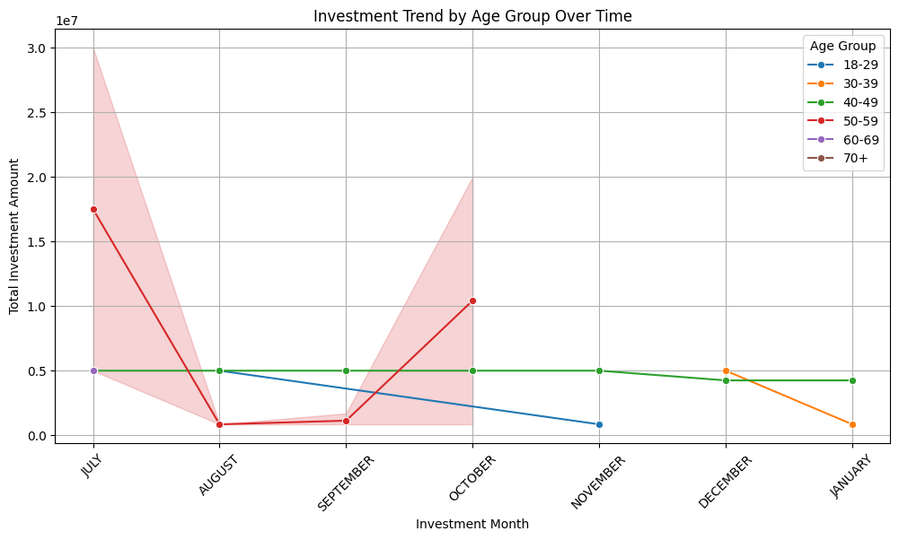

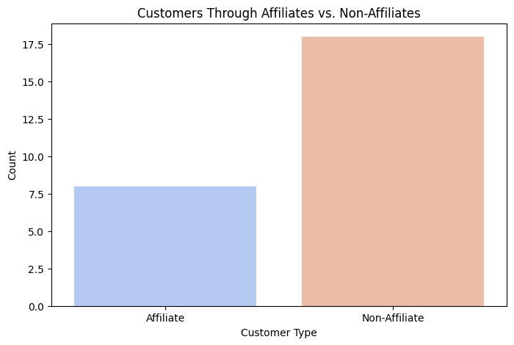

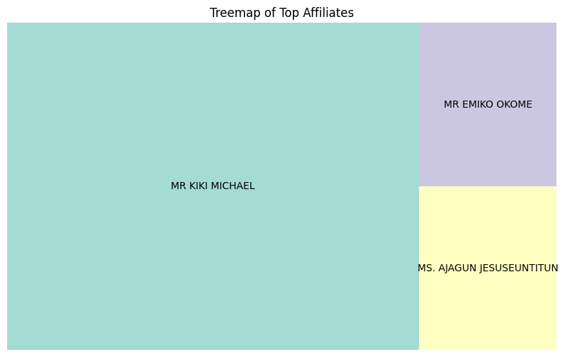

**Strategic Planning for Seasonal Trends**

* + Prepare for **investment surges** in peak months by ensuring adequate resources and streamlined processes.
  + Conduct surveys or interviews with investors to understand the rapid three month **investment drop-off** and address potential concerns.
  + Implement **targeted investment strategies** during the low-performing months to maintain consistency.
  + Analyze external factors (e.g. economic conditions, policy changes) that influence investment seasonality.

**Data-Driven Decision Making**

* + Continuously monitor investment trends to **adapt strategies proactively**.
  + Use historical data to forecast **future investment behavior** and optimize portfolio offerings.

****6. Conclusion****

### *This detailed analytics meticulously highlights significant investments trends, the investors patterns of investments, the affiliates and their roles in the investments made, and most importantly the key areas of focus to enhance investors’ engagements. By leveraging the above data-driven insights,* ***UMéRA*** *can make informed strategic decisions that maximize investment potential and align offerings with market demand.*